**House price prediction using machine learning**

**Program:**

In [1]:

Model_rf=RandomForestRegression(n_estimators=50)

In[2]:

Model_rf.fit(X_train_scal,Y_train)

In[3]:

Print(r2_score(Y_test,Prediction2))

Print(mean_absolute_error(Y_test, Prediction2))

Print (mean_squared_error(Y_test, Prediction2))

Output:

Out[3]:

-0.0006222175925689744

286137.81086908665

128209033251.4034

**Program:**

Data.head()

Avg. Area Income Avg. Area House Age Avg. Area Number of Rooms Avg. Area Number of Bedrooms Area Population Price Address

0 79545.458574 5.682861 7.009188 4.09 23086.800503 1.059034e+06 208 Michael Ferry Apt. 674\nLaurabury, NE 3701...

1 79248.642455 6.002900 6.730821 3.09 40173.072174 1.505891e+06 188 Johnson Views Suite 079\nLake Kathleen, CA...

2 61287.067179 5.865890 8.512727 5.13 36882.159400 1.058988e+06 9127 Elizabeth Stravenue\nDanieltown, WI 06482...

3 63345.240046 7.188236 5.586729 3.26 34310.242831 1.260617e+06 USS Barnett\nFPO AP 44820

4 59982.197226 5.040555 7.839388 4.23 26354.109472 6.309435e+05 USNS Raymond\nFPO AE 09386

Step:1

b.histplot(x = data[‘Price’]);

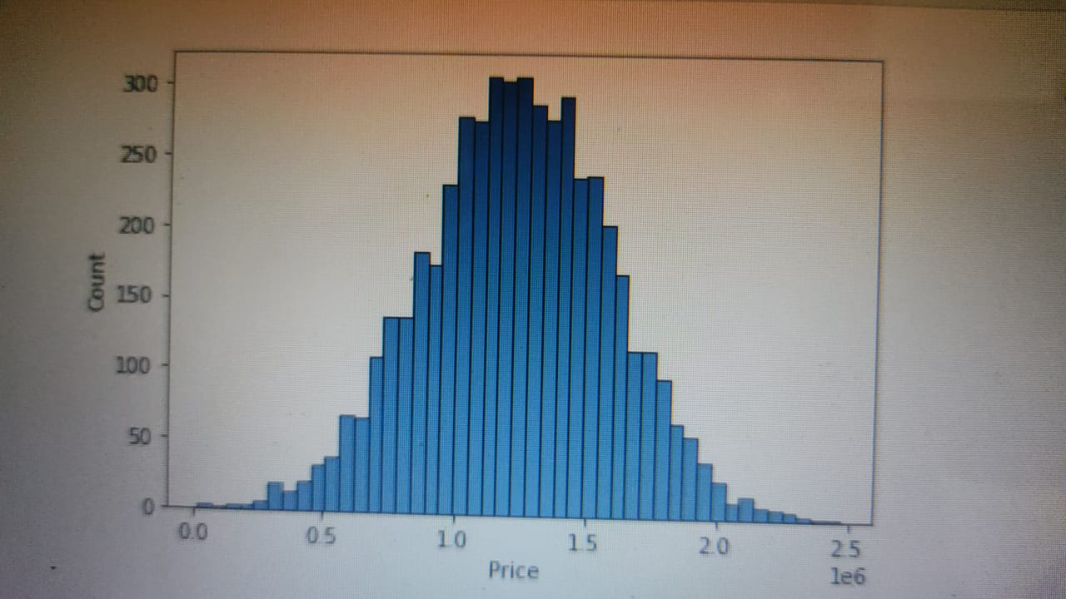Output 1:

Step:2

Sb.histplot(x = data[‘Avg. Area Income’]);

Output 2:



Step 3:

Sb.histplot(x = data[‘Avg. Area House Age’])

Output 3:

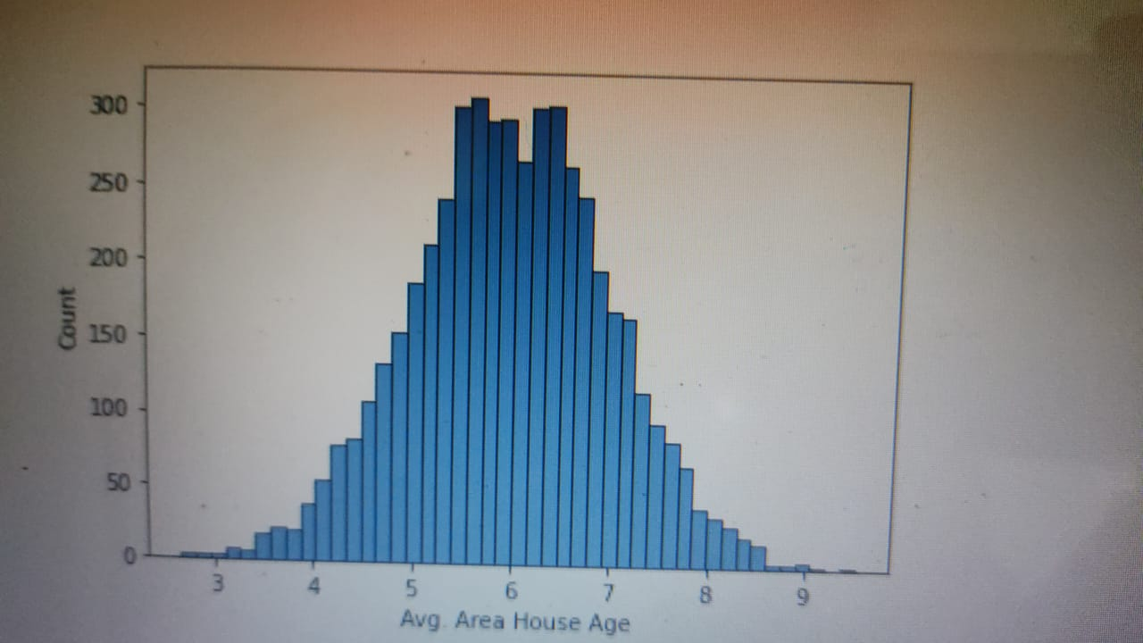

Step4:

Sb.histplot(x = data[‘Avg. Area Number of Rooms’]);

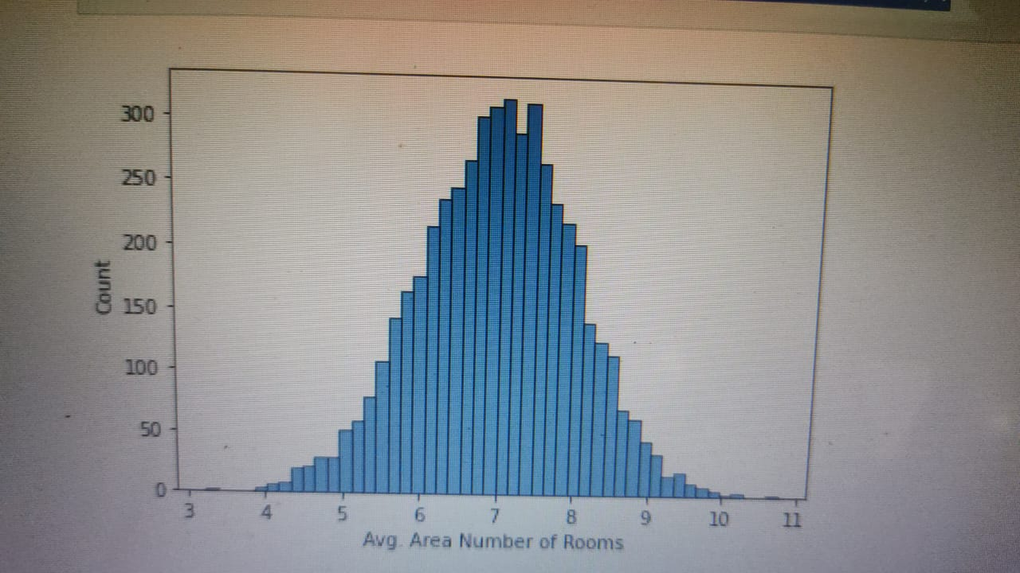 Output 4:

Step:5

Sb.histplot(x = data[‘Avg. Area Number of Bedrooms’]);

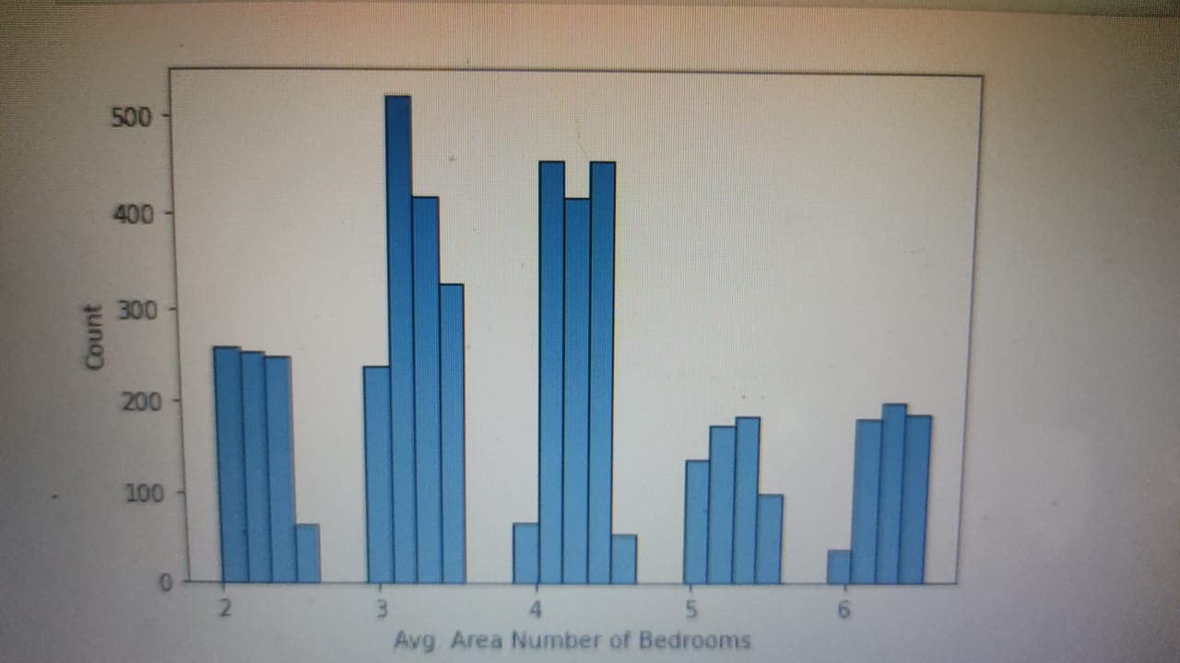 Output 5:

Step6:

Sb.histplot(x = data[‘Area Population’]);

Output 6:

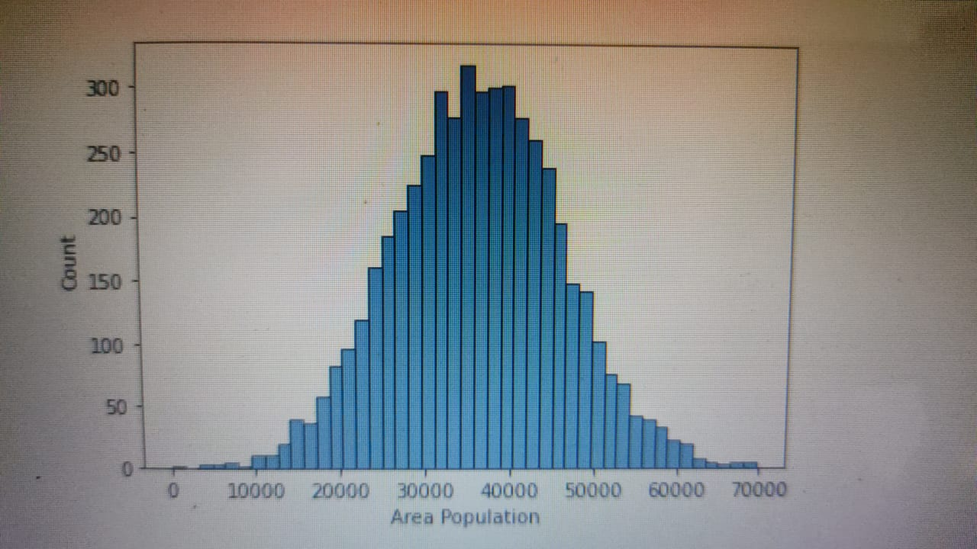

Step7:

Sb.histplot(x = data[‘Price’]);

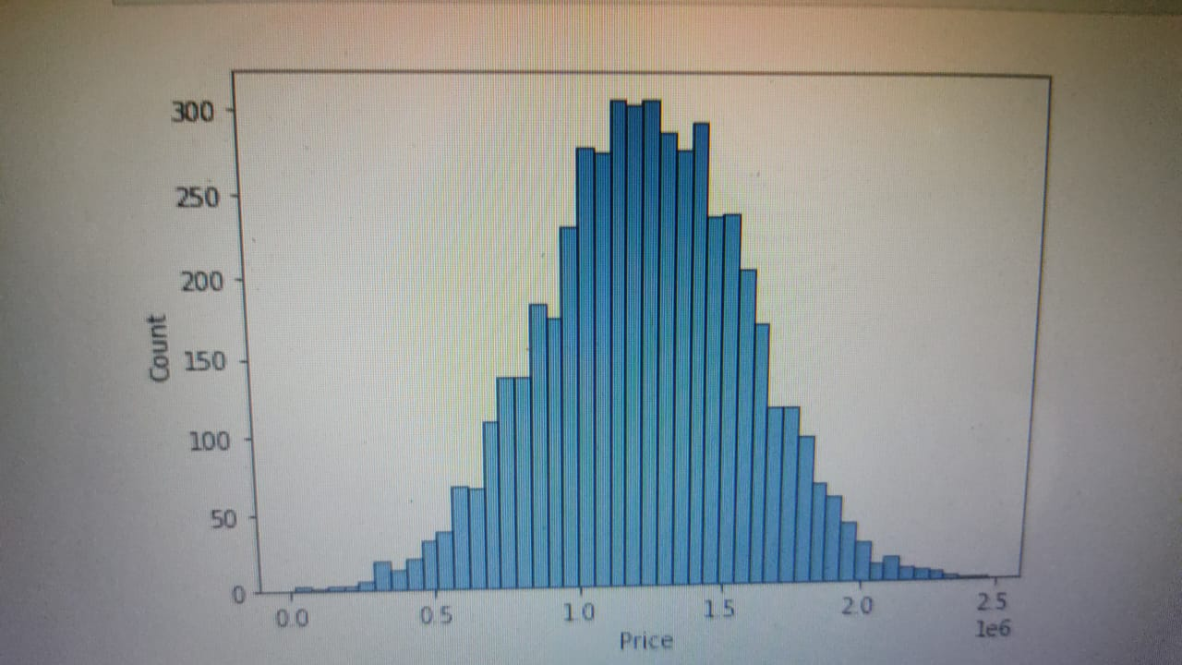 Output 7:

Step8:

Sb.regplot(x = data[‘Avg. Area House Age’], y = data[‘Price’])

Output 8:

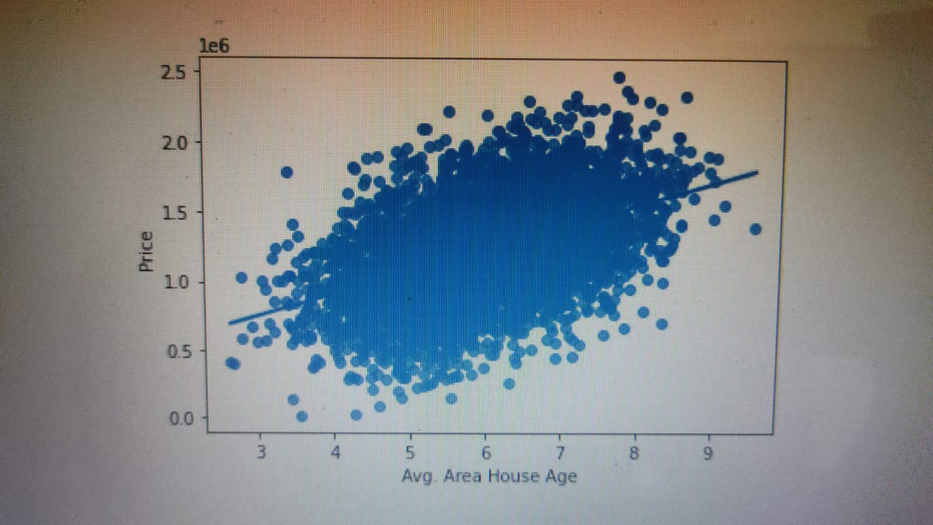

Step9:

Sb.regplot(x = data[‘Avg. Area Income’], y = data[‘Price’]);

Output 9:

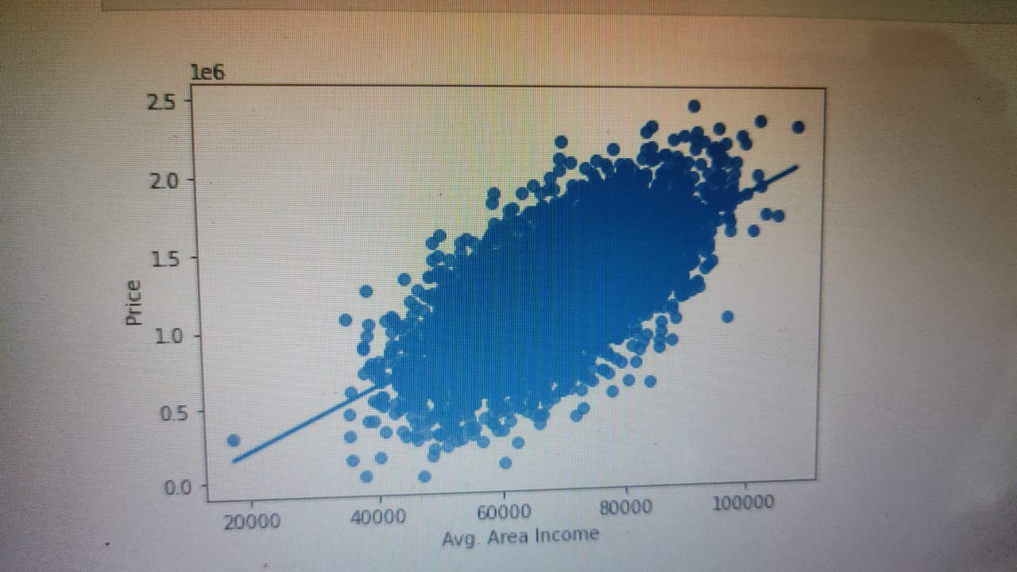

Step 10:

Sb.regplot(x = data[‘Avg. Area Number of Rooms’], y = data[‘Price’]);

Output 10:

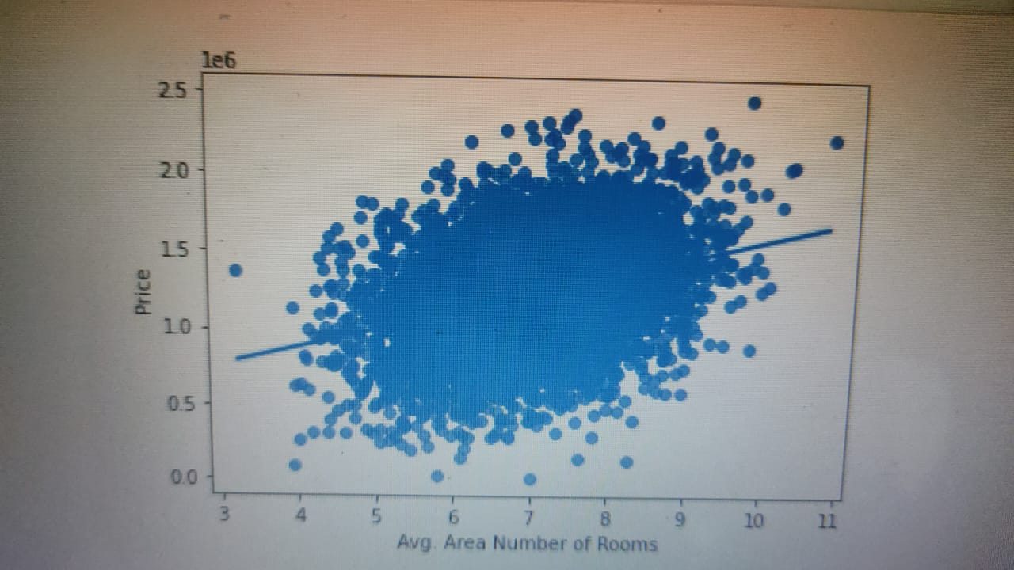

Step11:

Sb.regplot(x = data[‘Area Population’], y = data[‘Price’]);

Output 11:

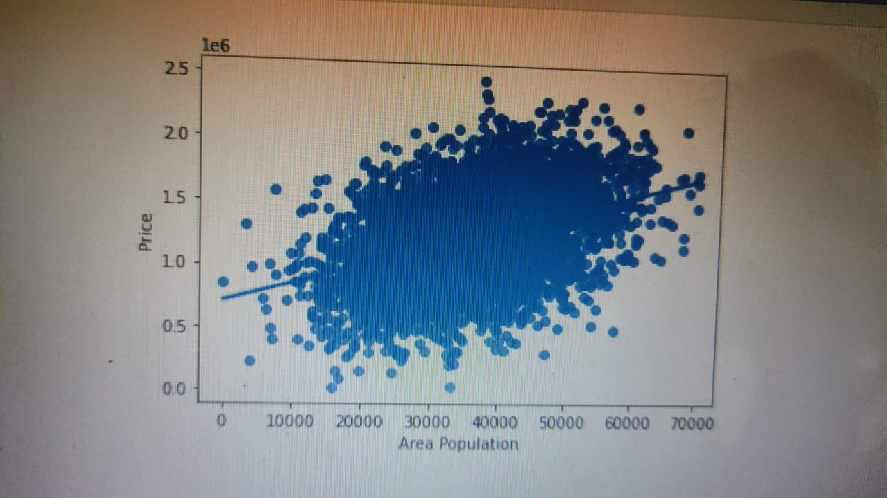

Step 12:

Sb.regplot(x = data[‘Avg. Area Number of Bedrooms’], y = data[‘Price’]);

Output 12:

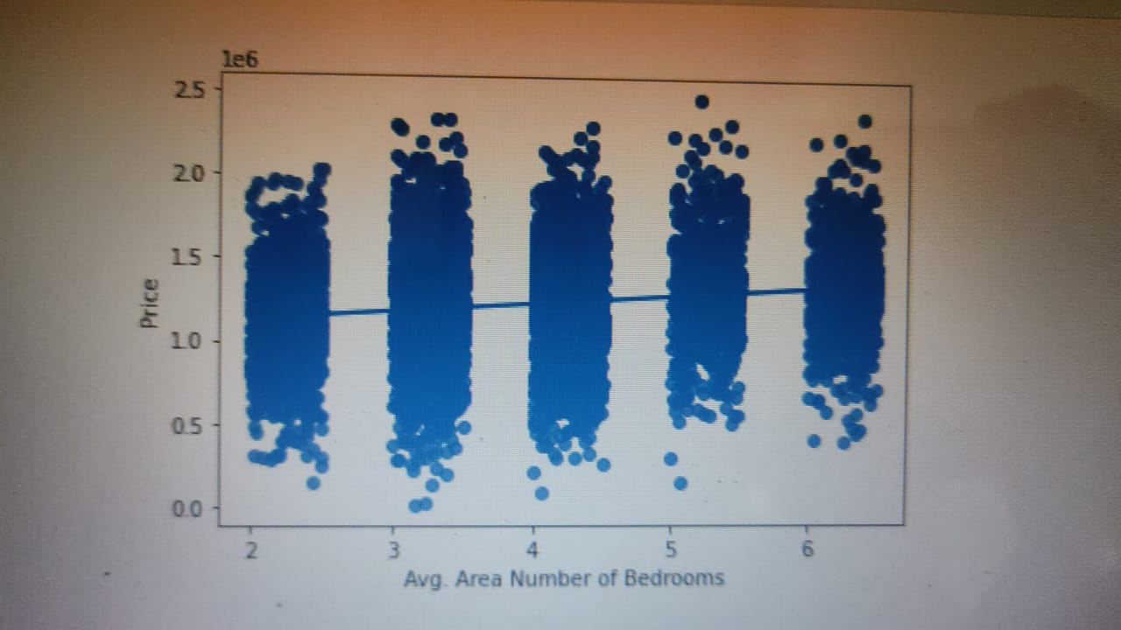

Analysis

Price increases with all the variables

Price increases sharply with increase in Average Area Income

Plt.figure(figsize = (15, 10))

Sb.heatmap(data.corr(), annot = True, cmap = ‘mako’)

Y = data[‘Price’]

X = data.drop([‘Price’, ‘Address’], axis = 1)

From sklearn.model_selection import train_test_split

From sklearn.metrics import mean_absolute_error

From sklearn.metrics import mean_squared_error

From sklearn.ensemble import RandomForestRegressor

Train_X, val_X, train_y, val_y = train_test_split(X, y, random_state = 42)

Model = RandomForestRegressor(random_state = 1)

Model.fit(train_X, train_y)

Preds = model.predict(val_X)

Print(“MAE: “, mean_absolute_error(preds, val_y))

Print(“RMSE: “, np.sqrt(mean_squared_error(preds, val_y)))

MAE: 93812.37073246129

RMSE: 118380.48325186648

Output:

